Java Basics

Class, Object and Method

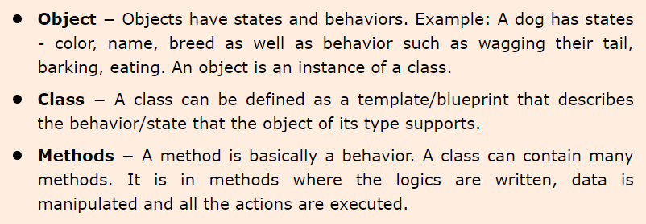

Basic Syntax

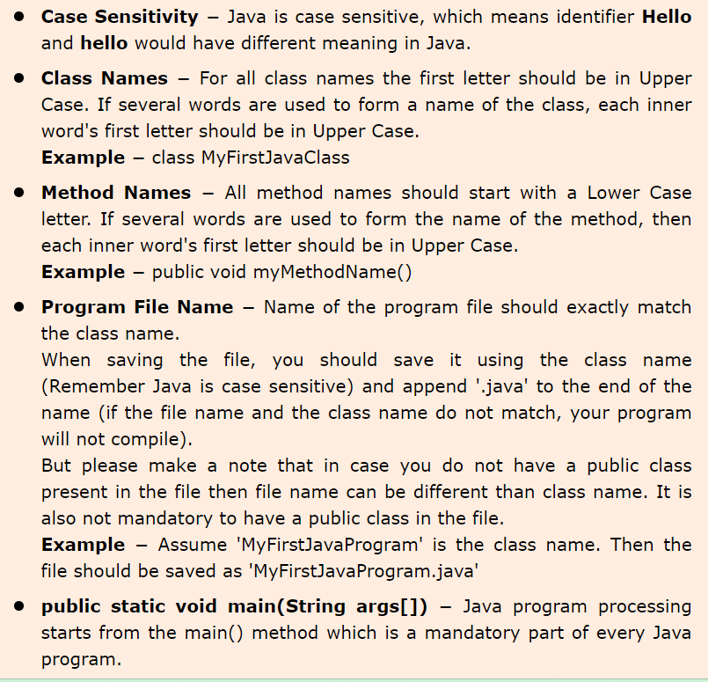

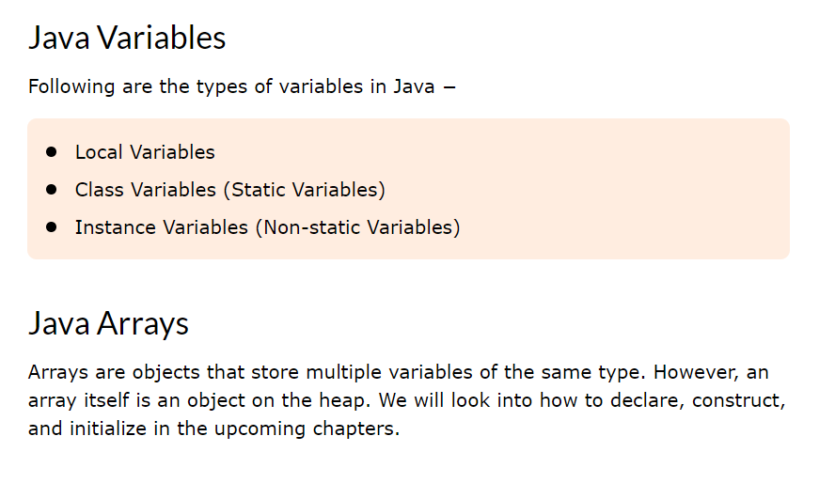

https://meet.google.com/fwk-emhv-ytb